ELL409 Assignment 2 Report

Kshitij Alwadhi (2019EE10577)

22nd October 2021

1. **Introduction**

In this assignment, we experiment with the use of SVMs for both binary and multiclass classification problems, and understand the  
effects of varying various hyperparameters therein.

1. **Part 1A**

**2.1 Formulating the problem for CVXOPT.**

We have the following optimization problem in the case of an SVM with L1 regularization:

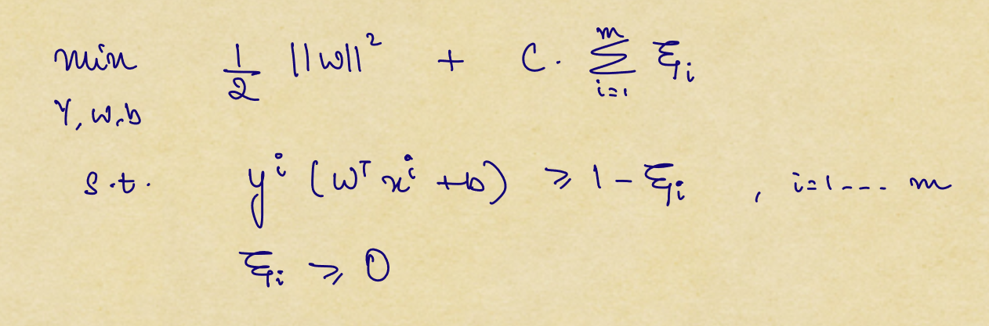

To solve this problem, we take the help of Lagrangian Multipliers and proceed using KKT conditions. (The following results are taken from the **CS229 SVM notes**)

The Lagrangian for the optimization problem is:

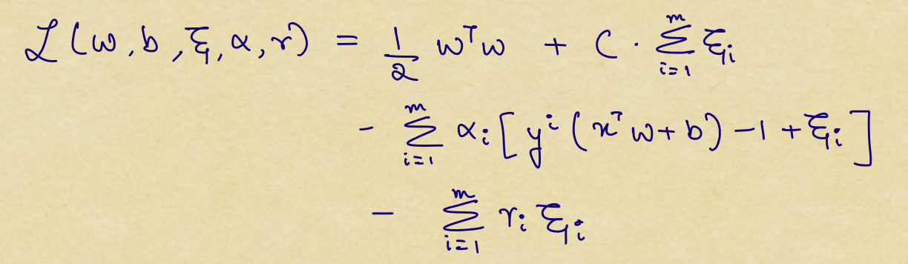

After applying the KKT conditions (taking the respective partial derivatives), we get the following optimization problem:

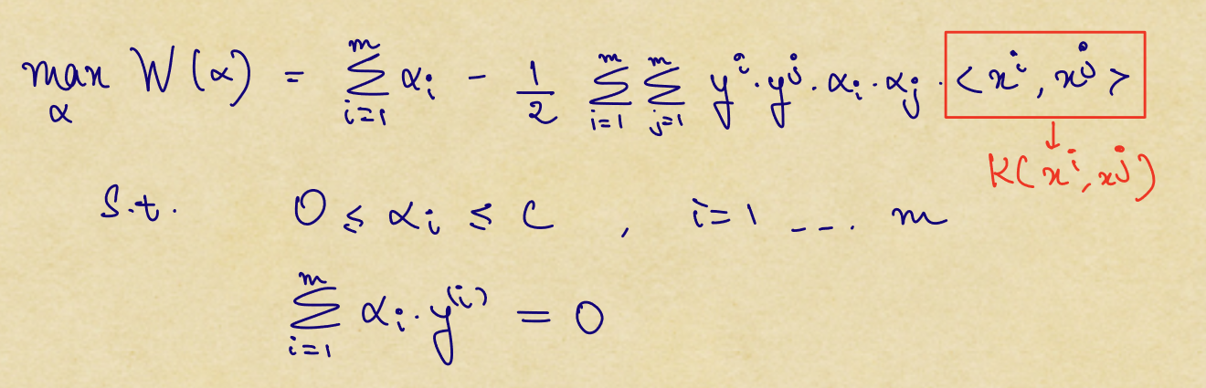

This is equivalent to the following minimization problem:

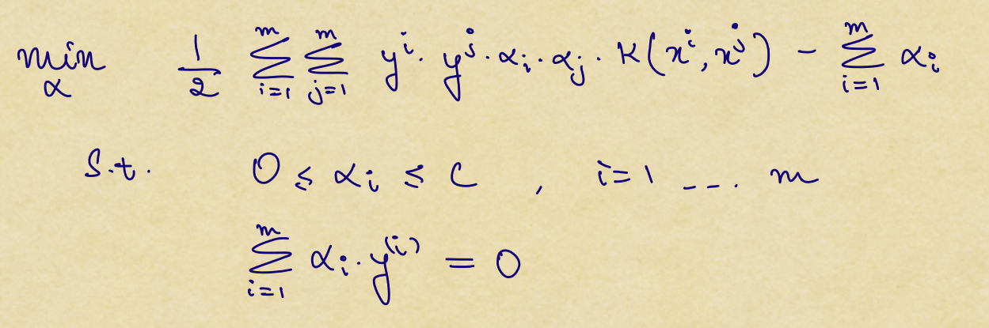

To simplify things, we define the following:



Now, our optimization problem looks like:

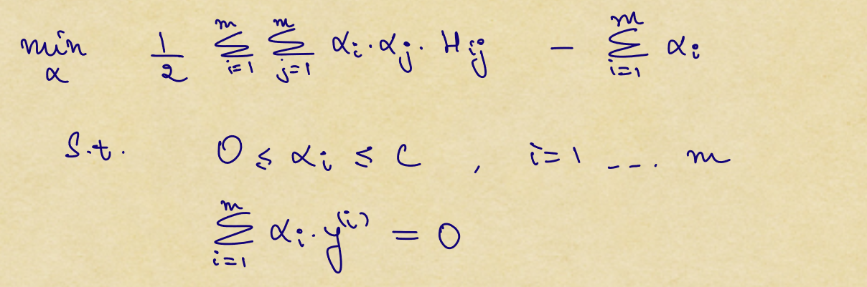

Now this is a quadratic optimization problem but we need to convert it into a form which we can feed into CVXOPT.

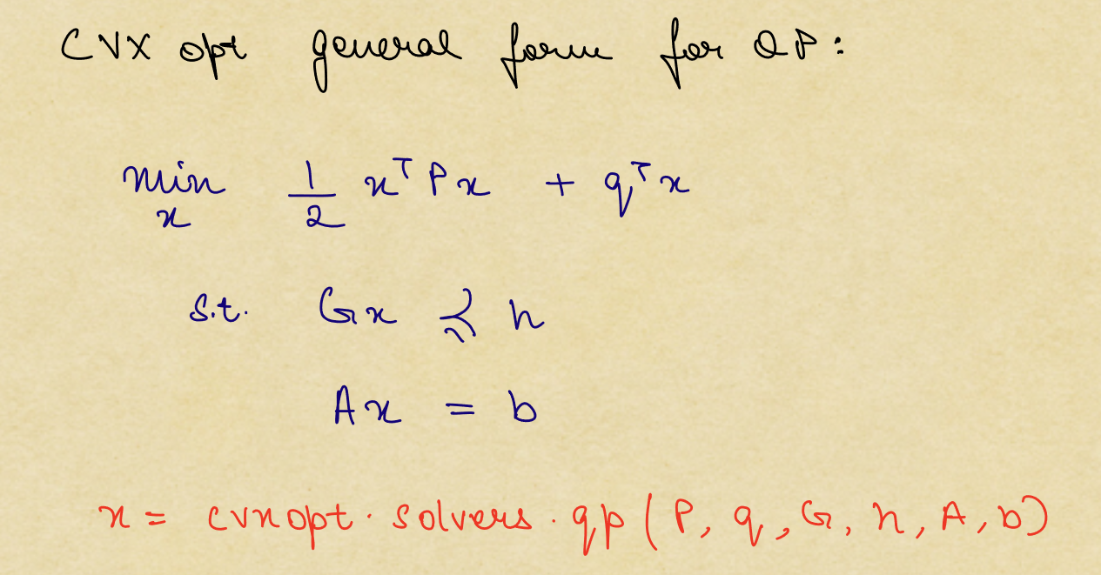

We can convert our optimization problem to the following form so that it resembles the form of QP in CVXOPT:

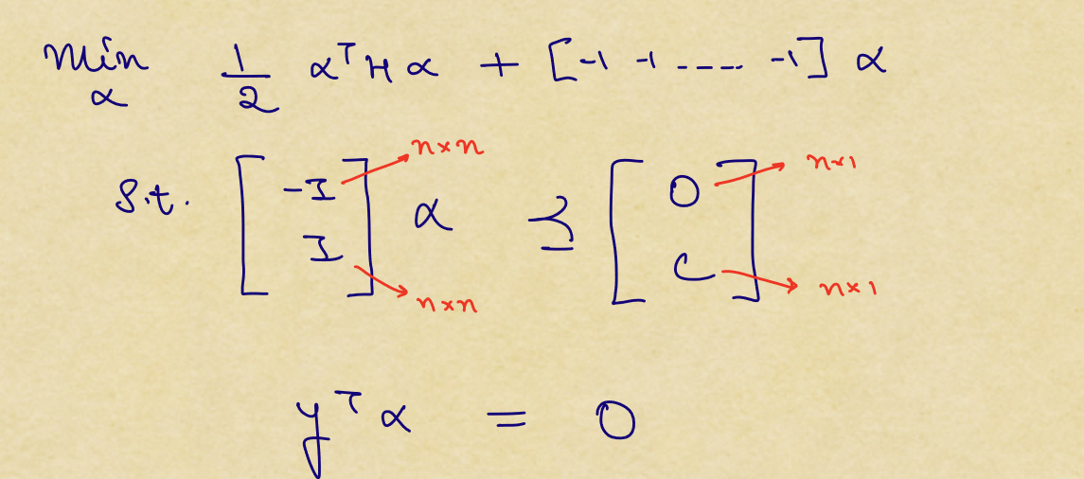

On comparing the terms, we have the following:

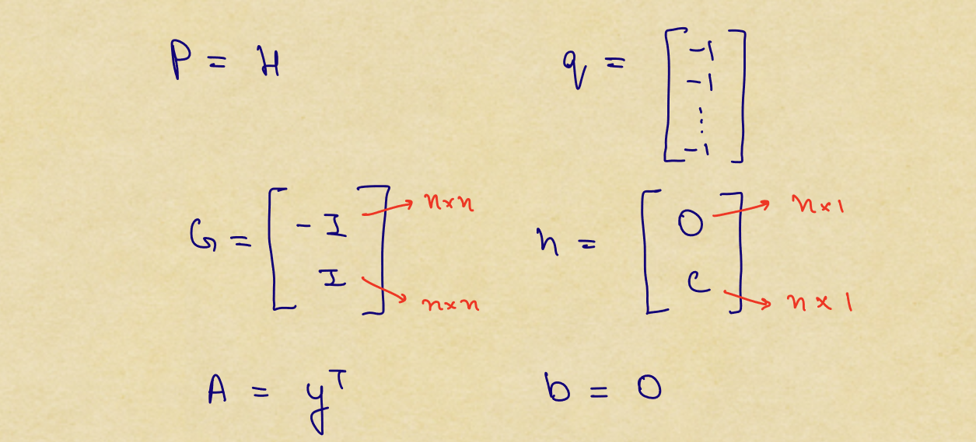

This can be solved using CVXOPT by the following:

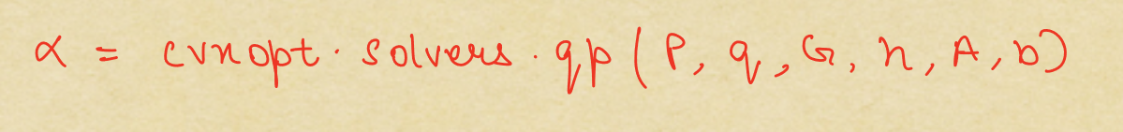

The following is the code which solves for α using CVXOPT:

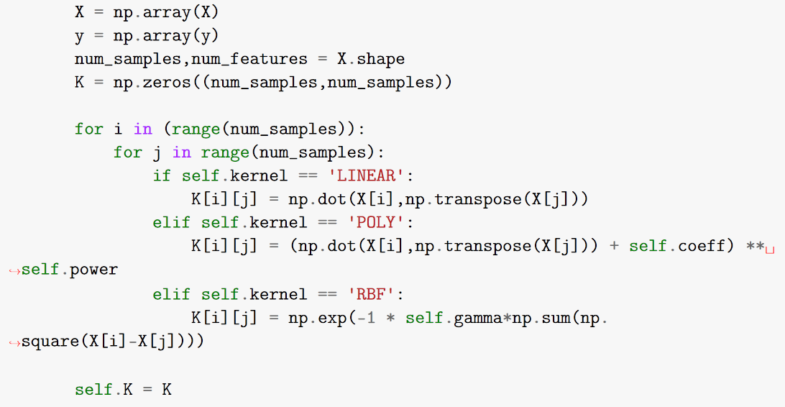

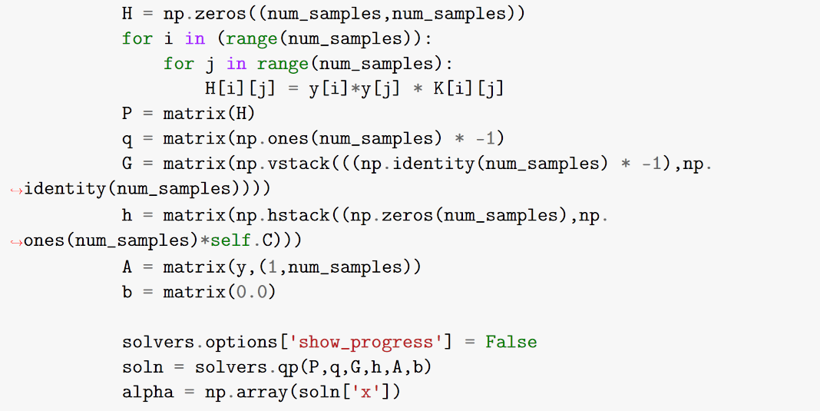

Now that we have solved for the value of α, we need to determine our supporting vectors, store the non-zero α values and also calculate the value of b so that we can make predictions.

The equation of separating hyperplane is given by:

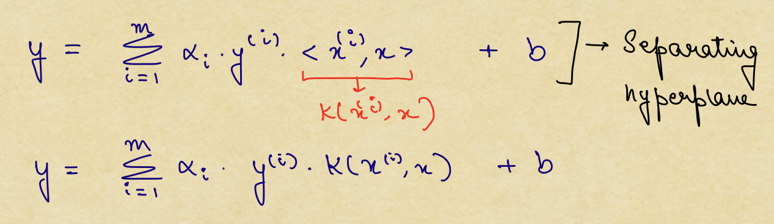

We know that the supporting vectors lie on the separating hyperplanes, so we exploit that and write the following:

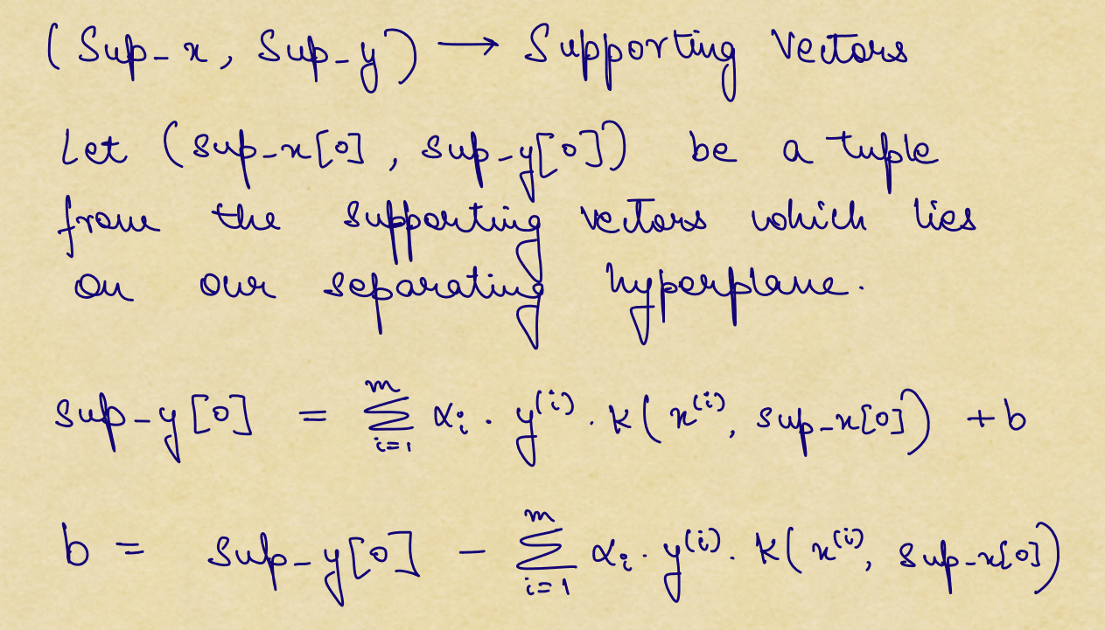

We find the value of b using the above formula. Also, we can directly find the indices of the supporting vectors by checking where the indices of α are non-zero. These steps are performed using the following code:

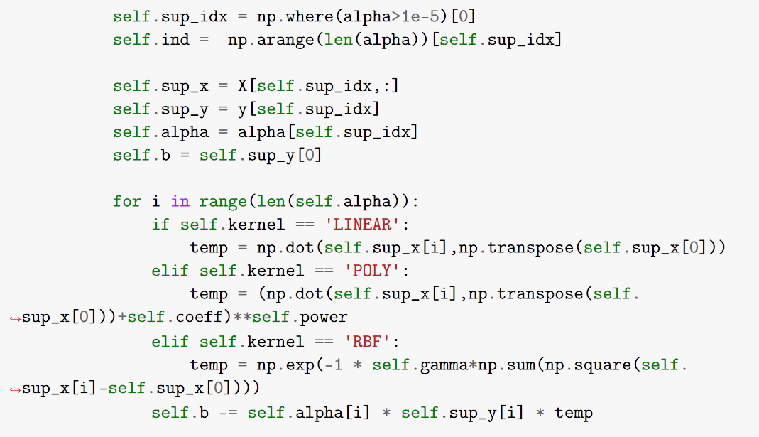

For deciding the class of the input X, we see which side of the separating hyperplane our data point is and give it a +1 class if it’s above the hyperplane and -1 if it’s below the hyperplane. This is performed by the following code snippet:

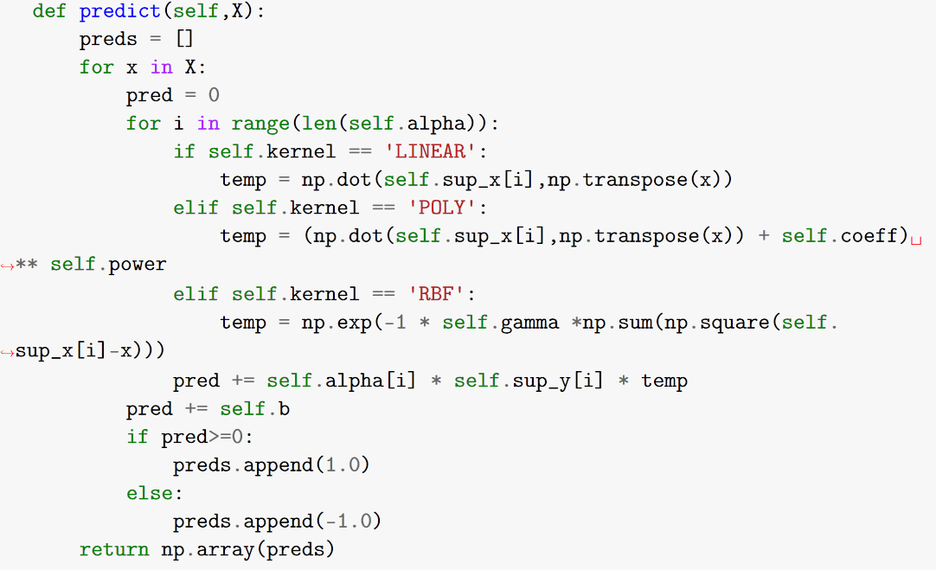

* 1. **Binary Classification**

In all of the analysis, I have used 5-fold Cross Validation and then averaged out the train and test accuracy for comparing the results of the various hyperparameter settings.

**2.2.1** First we do the analysis for: **C1 = 1, C2 = 8**

Using **Linear Kernel** we get the following results:

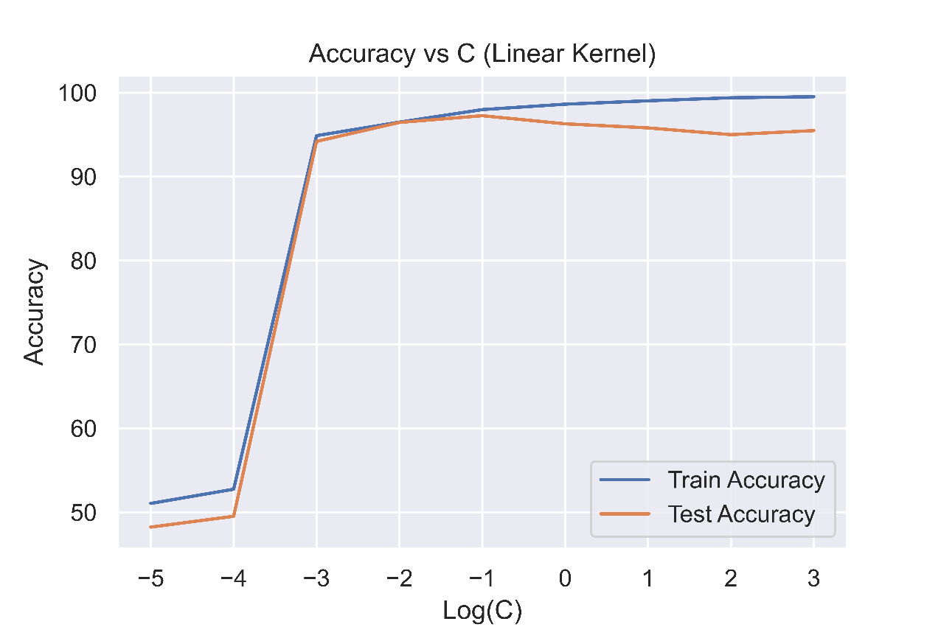

(Accuracy vs C (Linear Kernel) for 25 features)

From the above plot, we can see that when the value of C is very low (<0.001), the model is underfitting the data but as the value of C increases, the model starts to fit the data (good fit) and we observe a peak Test accuracy at C = 0.1. Beyond this (C>0.1), we start to see that training accuracy creeps up to almost 100% and the test accuracy starts falling, hence indicating overfitting.

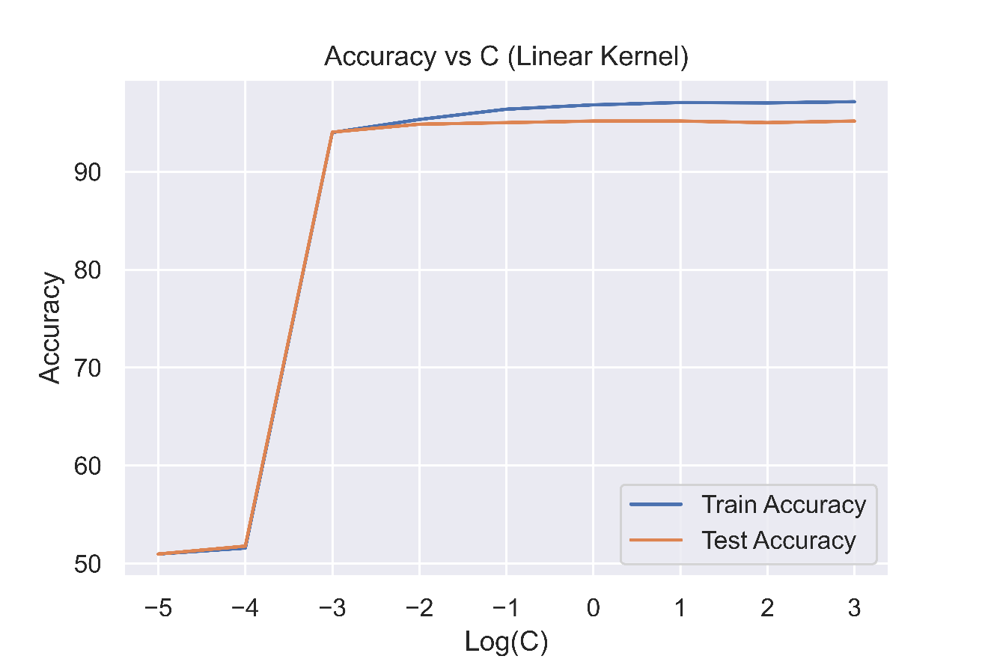

(Accuracy vs C (Linear Kernel) for 10 features)

Now, if we use only 10 features, we get a similar story, for C < 0.001, the model is underfitting the data and we get peak test accuracy at C = 0.01 beyond which the model starts overfitting the data.

There are two differences we observe here:

1. The peak test accuracy that we obtain when we use all 25 features is greater than when we use only 10 features.
2. The model is able to get a 100% train accuracy in the case of 25 features when C is significantly larger, however, this is not achievable in the case of 10 feature dataset.

Using **RBF kernel** we get the following results:

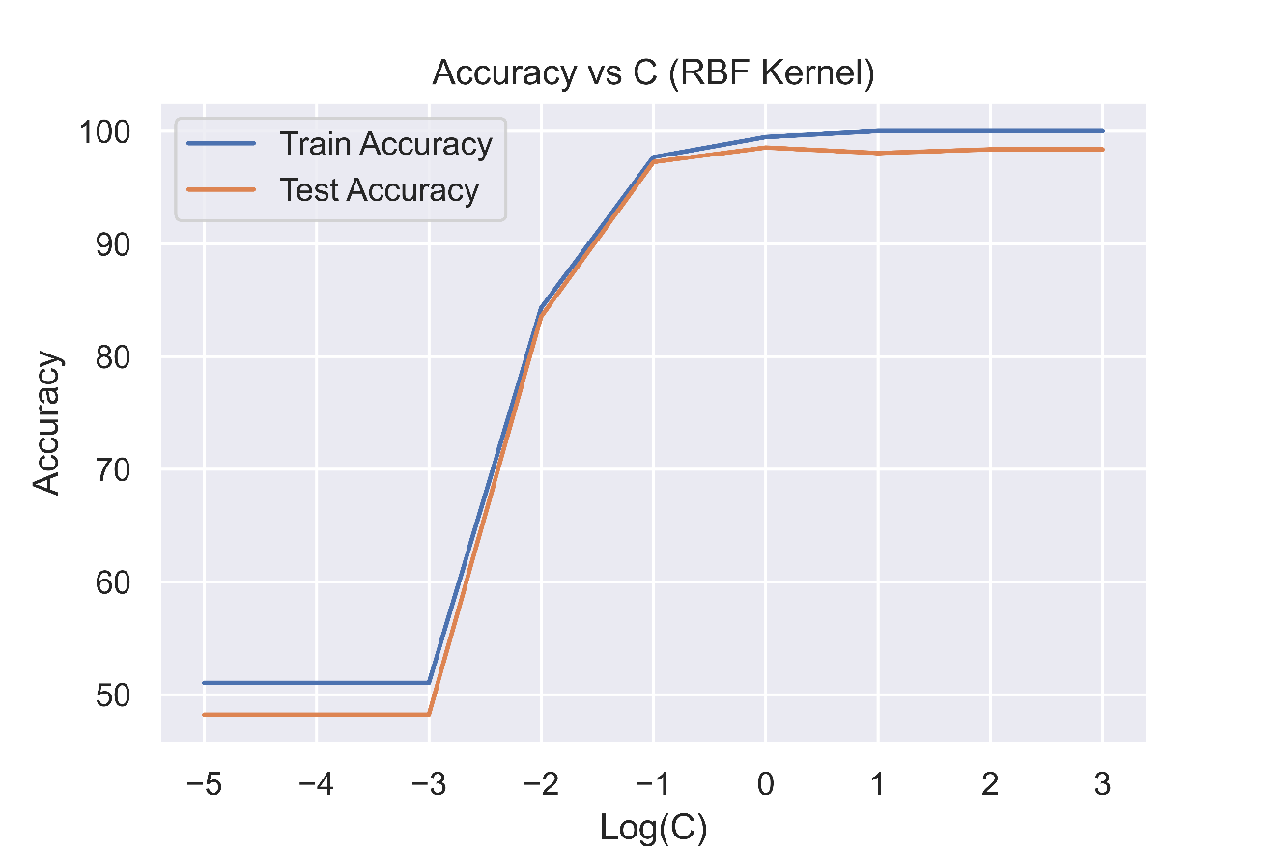

(Accuracy vs C (RBF Kernel) for 25 features)

In the case of RBF kernel, we have two parameters to play around with. For finding the appropriate value of C, we perform a logarithmic sweep while keeping the value of γ to be $\frac{1}{\# of features}$ as usually done by standard SVM libraries.

We observe the following:

|  |  |
| --- | --- |
| C < 1 | Underfitting |
| C = 1 | Best fit |
| C > 1 | Overfitting |

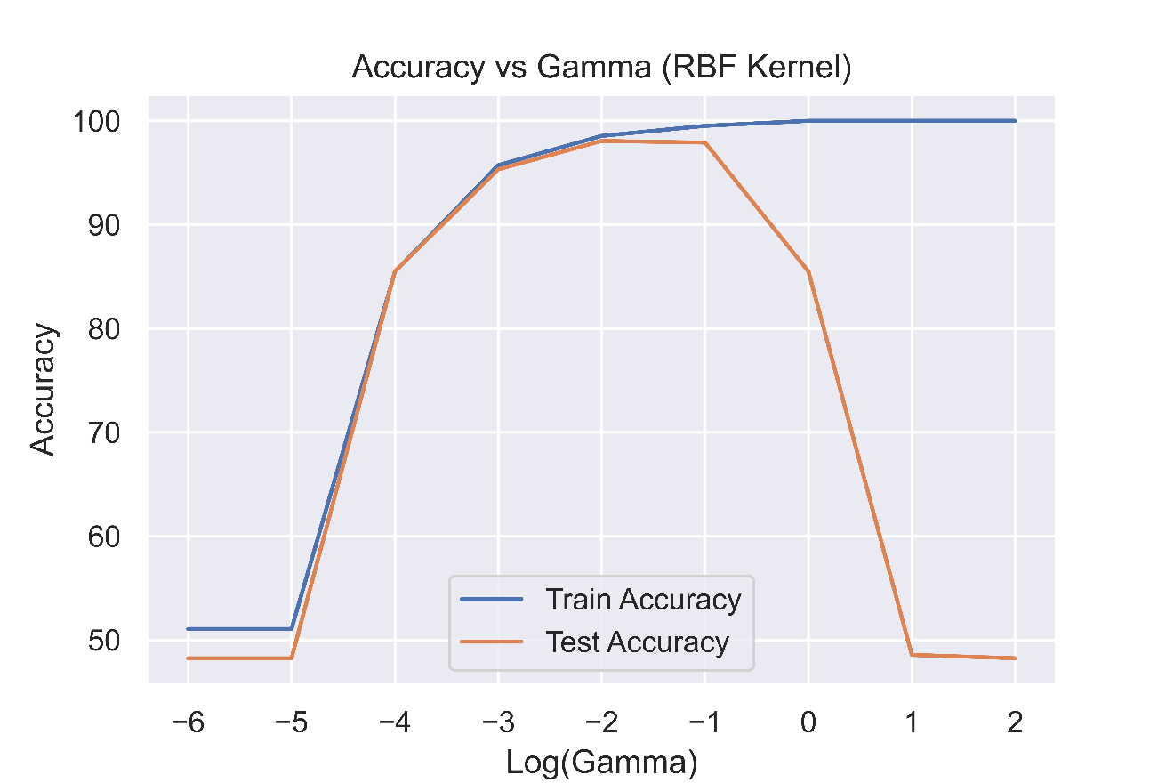

(Accuracy vs Gamma (RBF Kernel) for 25 features)

We also perform a logarithmic sweep over values of γ. We obtain the following result:

|  |  |
| --- | --- |
| γ < 0.01 | Underfitting |
| γ = 0.01 | Best fit |
| γ > 0.01 | Severe Overfitting |

Now for the case of 10 features:

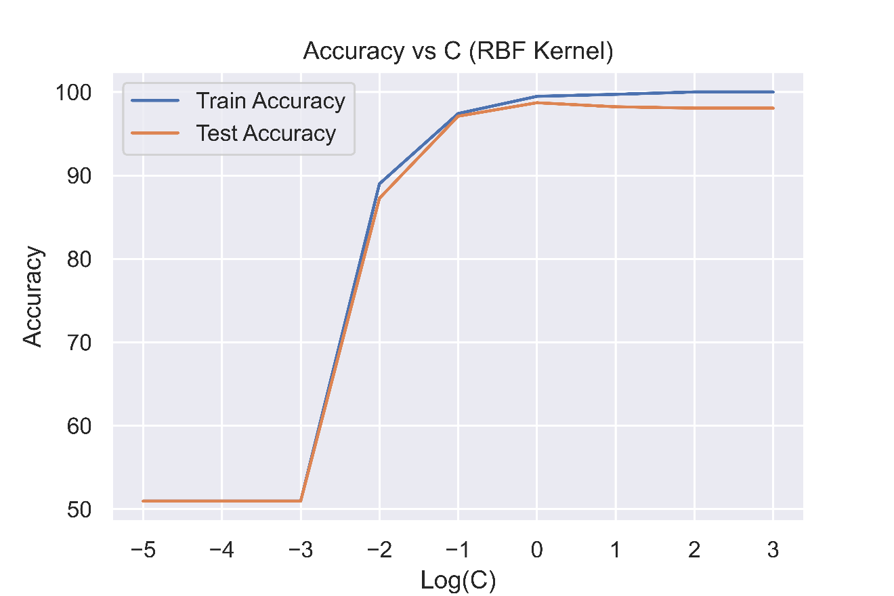

(Accuracy vs C (RBF Kernel) for 10 features)

Now, if we use only 10 features, we get a similar story, for C < 0.1, the model is underfitting the data and we get peak test accuracy at C = 1 beyond which the model starts overfitting the data.

|  |  |
| --- | --- |
| C < 1 | Underfitting |
| C = 1 | Best fit |
| C > 1 | Overfitting |

The main difference that we observe here is that the peak test accuracy is lower when we have 10 features instead of 25.

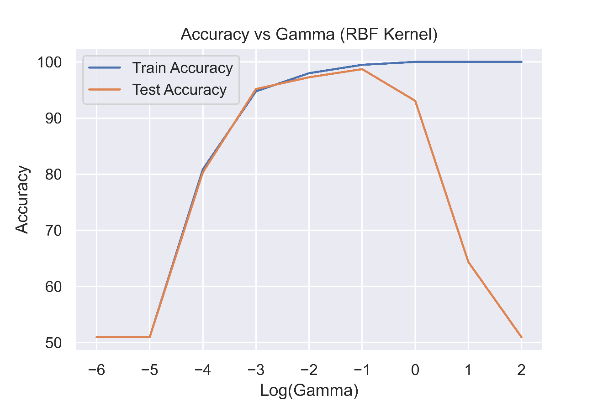

(Accuracy vs γ (RBF Kernel) for 10 features)

We get the following results after performing a logarithmic sweep over γ:

|  |  |
| --- | --- |
| γ < 0.1 | Underfitting |
| γ = 0.1 | Best fit |
| γ > 0.1 | Severe Overfitting |

One thing to note here is that the value of γ at which peak test accuracy occurred has changed from 0.01 to 0.1, this change however is not very significant as the test accuracy is very close on both of these values.

**2.2.2** Now we do the analysis for: **C1 = 3, C2 = 7**

Using **linear** kernel:

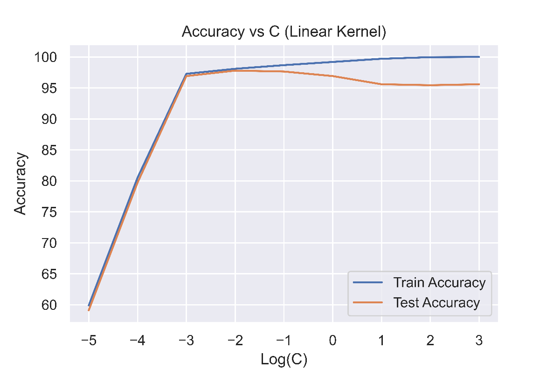

(Accuracy vs C (Linear Kernel) for 25 features)

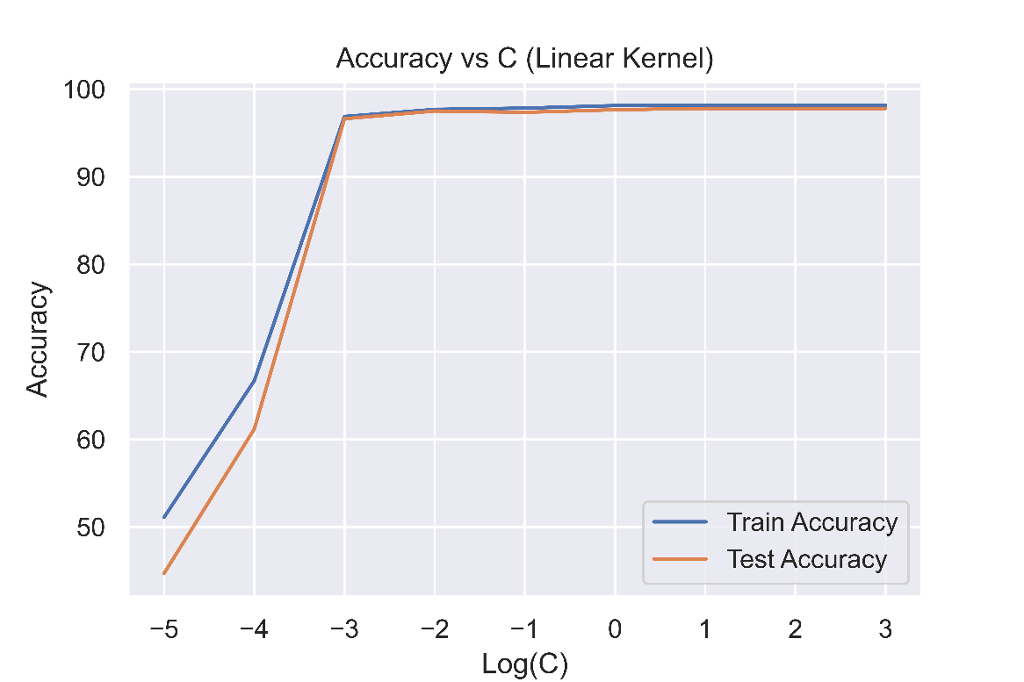(Accuracy vs C (Linear Kernel) for 10 features)

|  |  |
| --- | --- |
| C < 0.01 | Underfitting |
| C = 0.01 | Best fit |
| C > 0.01 | Overfitting |

(Consistent results)

Using **RBF** kernel:

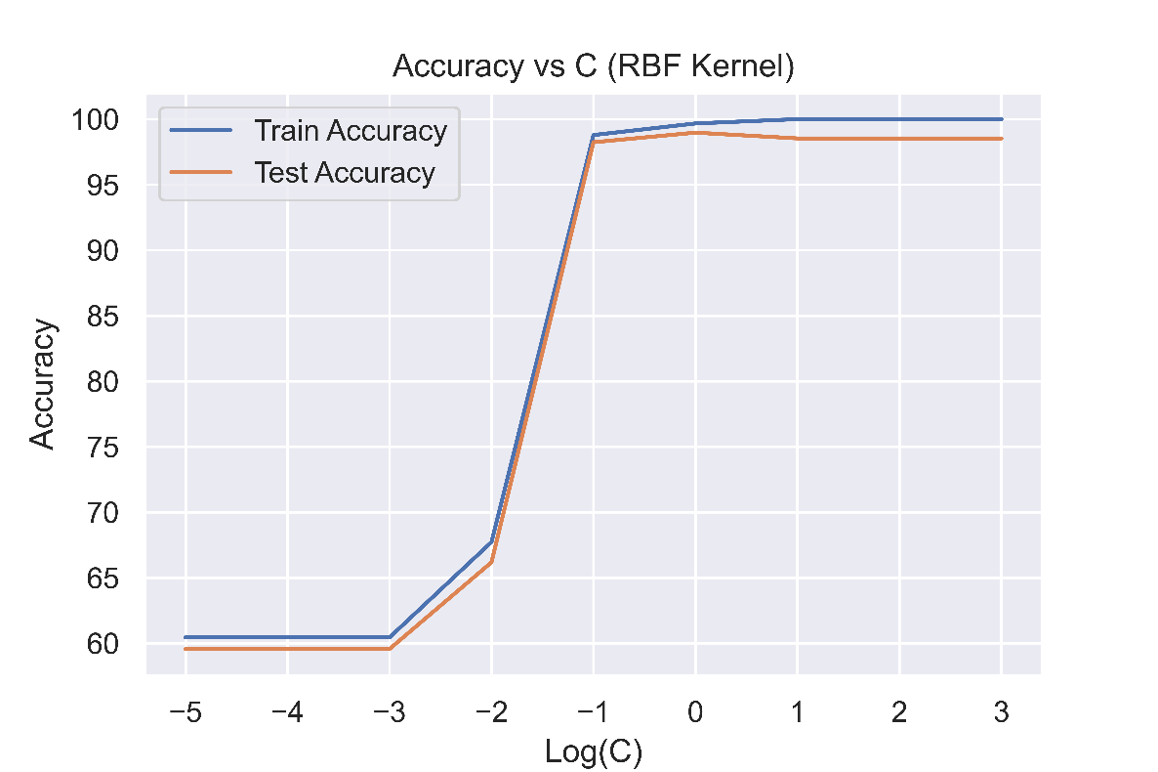

(Accuracy vs C (RBF Kernel) for 25 features)

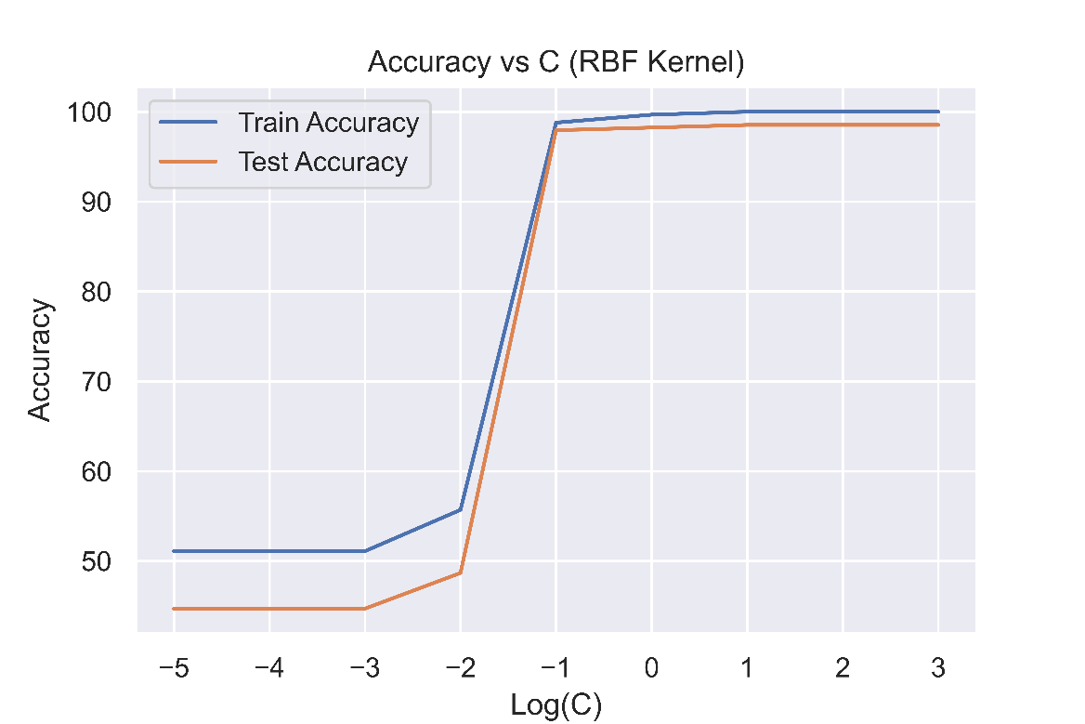

(Accuracy vs C (RBF Kernel) for 10 features)

|  |  |
| --- | --- |
| C < 0.1 | Underfitting |
| C = 0.1 | Best fit |
| C > 0.1 | Overfitting |

(Consistent results)

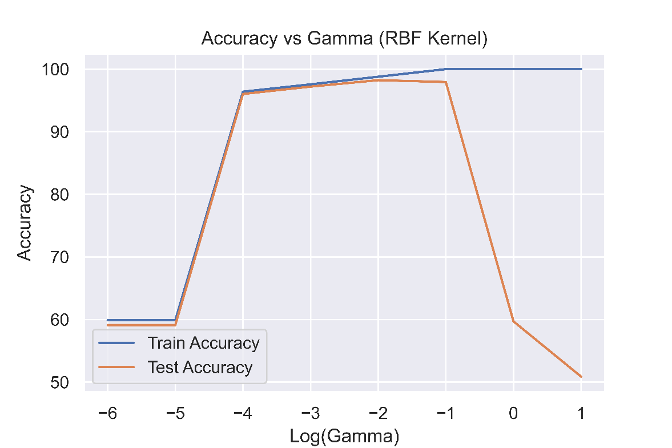

(Accuracy vs γ (RBF Kernel) for 25 features)

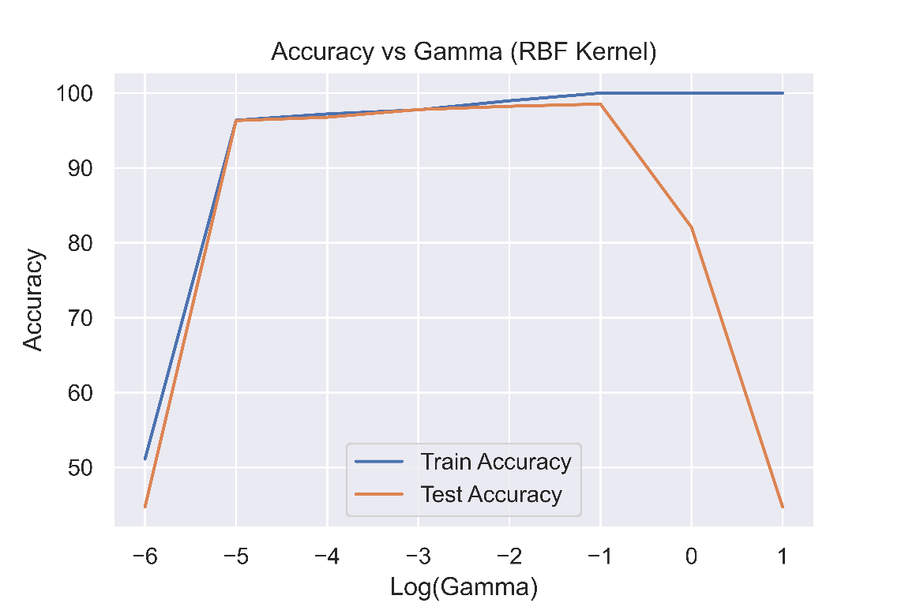

(Accuracy vs γ (RBF Kernel) for 10 features)

|  |  |
| --- | --- |
| γ < 0.1 | Underfitting |
| γ = 0.1 | Best fit |
| γ > 0.1 | Severe Overfitting |

(Consistent results)

**2.2.3** Now we do the analysis for: **C1 = 4, C2 = 9**

Using **linear** kernel:

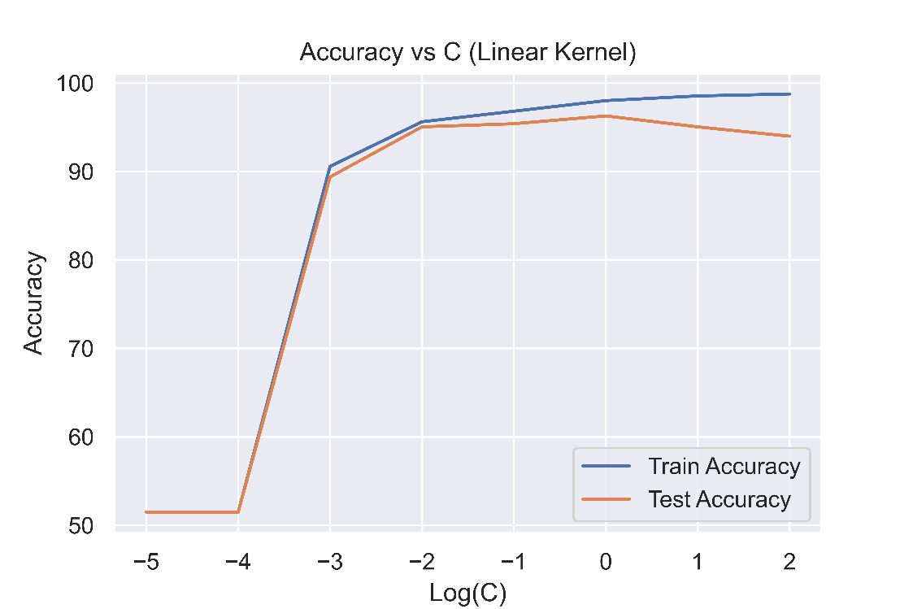

(Accuracy vs C (Linear Kernel) for 25 features)

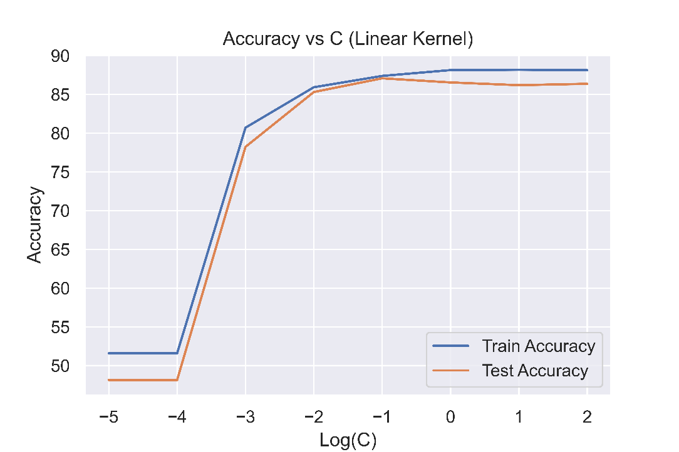

(Accuracy vs C (Linear Kernel) for 10 features)

|  |  |  |
| --- | --- | --- |
| 25 features | 10 features |  |
| C < 1 | C < 0.1 | Underfitting |
| C = 1 | C = 0.1 | Best fit |
| C > 1 | C > 0.1 | Overfitting |

Using **RBF** kernel:

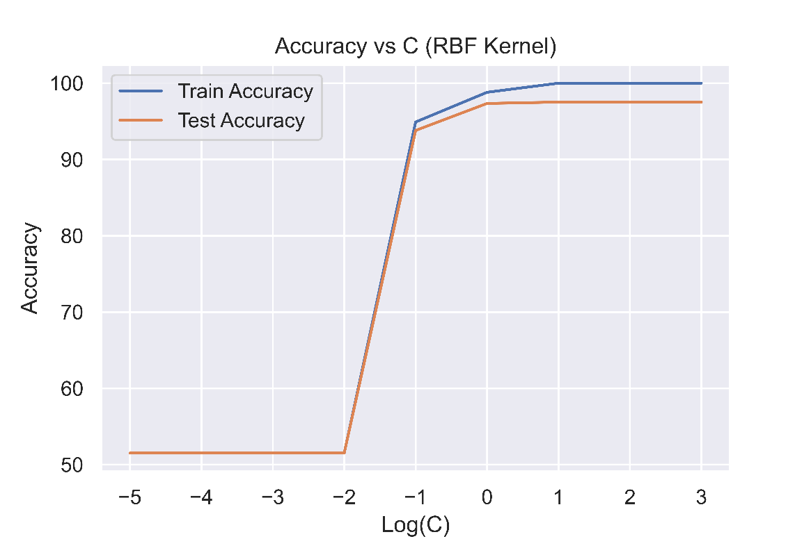

(Accuracy vs C (RBF Kernel) for 25 features)

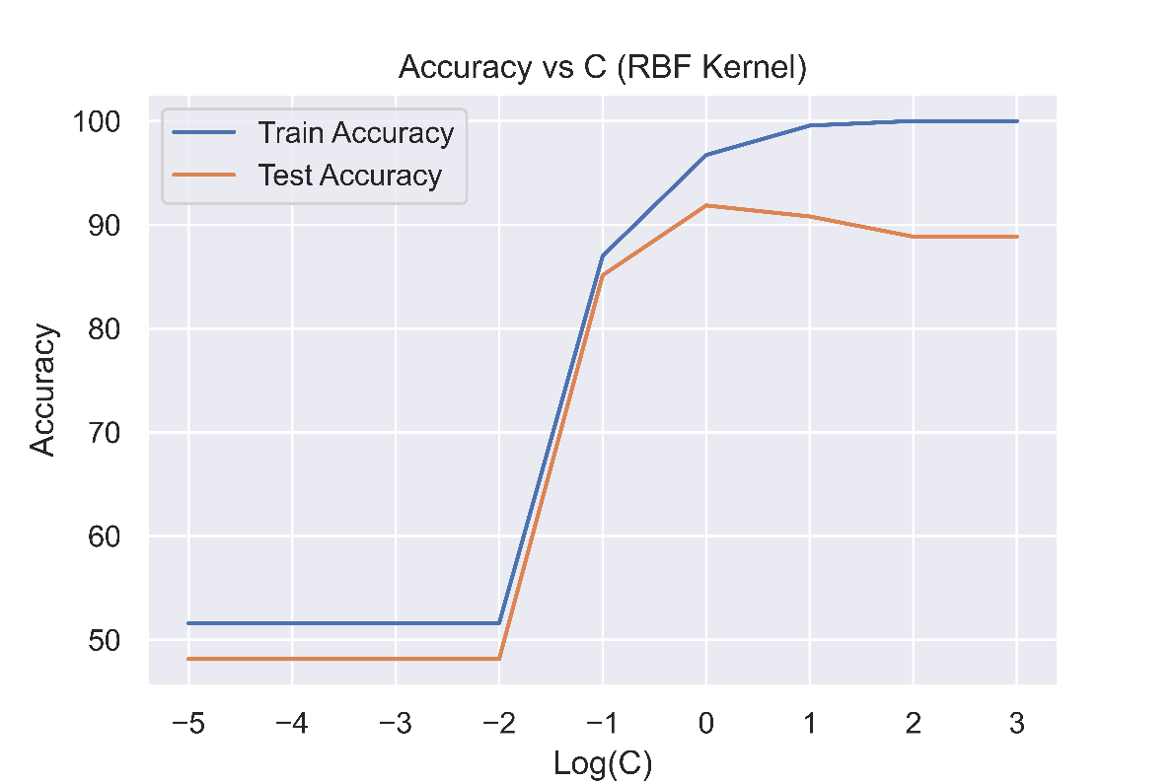

(Accuracy vs C (RBF Kernel) for 10 features)

|  |  |
| --- | --- |
| C < 1 | Underfitting |
| C = 1 | Best fit |
| C > 1 | Overfitting |

(Consistent results)

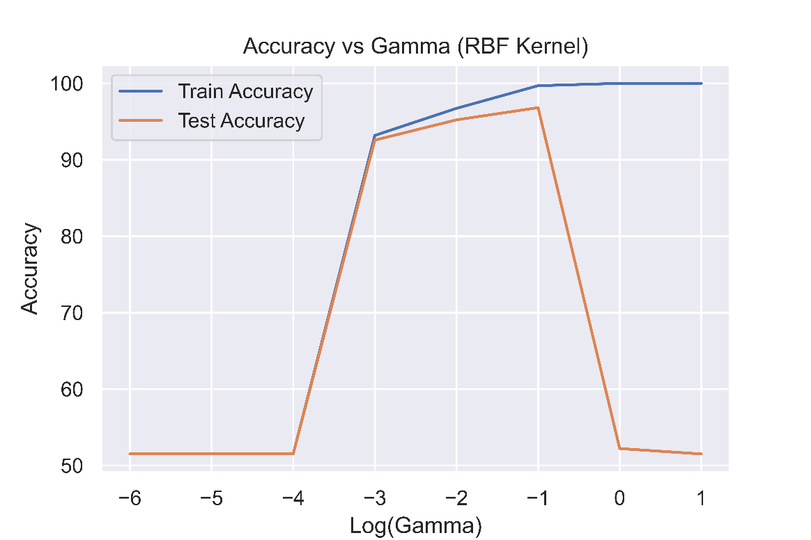

(Accuracy vs γ (RBF Kernel) for 25 features)

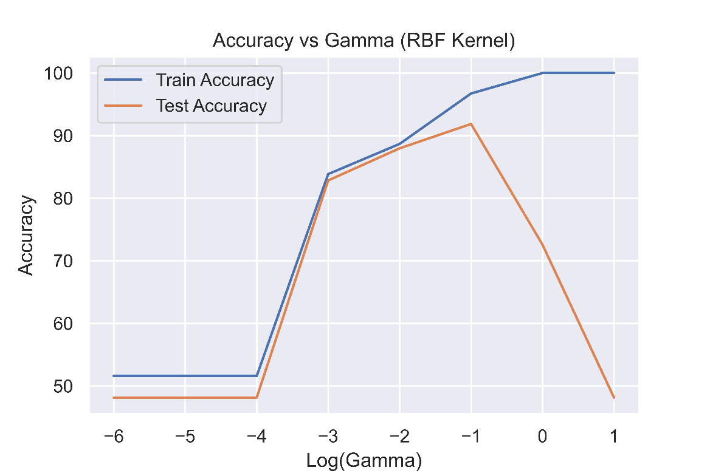

(Accuracy vs γ (RBF Kernel) for 10 features)

|  |  |
| --- | --- |
| γ < 0.1 | Underfitting |
| γ = 0.1 | Best fit |
| γ > 0.1 | Severe Overfitting |

(Consistent results)

**2.2.4 Comparison of Hyperparameters**

Below, I have tabulated the value of the hyperparameters at which we got the best fit while running the logarithmic sweep of the respective parameters for the three pairs of classes that we took:

|  |  |  |  |
| --- | --- | --- | --- |
|  | **Class C1,C2** | | |
| **(1,8)** | **(3,7)** | **(4,9)** |
| **Linear (C)** | 0.1 | 0.01 | 0.1 |
| **RBF (C)** | 1 | 0.1 | 1 |
| **RBF (γ)** | 0.01 | 0.1 | 0.1 |

We observe that there are slight differences in the value of the hyperparameters at which we obtain the peak test accuracy for the three pairs of classes that we took however, the difference is not large. It’s usually just a factor of 10 and despite that, the accuracies are fairly close in some cases, especially when we are considering the value of the C hyperparameter.

* 1. **Multiclass Classification**

In this part of the assignment, we use the full dataset given to us (all 10 classes) and build a multiclass SVM classifier. For all the comparisons, we perform a 5-fold cross validation.

**2.3.1 Methods used by LIBSVM library.**

In my experiments, I use the LIBSVM library for python. As per its documentation given at [libsvm.pdf](https://www.csie.ntu.edu.tw/~cjlin/papers/libsvm.pdf), LIBSVM uses “one-against-one” approach for multiclass classification. Since in our dataset, we have 10 classes, then 10*9/2 = 45 classifiers are constructed and each one trains data from two classes. During the classification, the library uses a voting strategy in which each binary classification is considered to be a voting where votes can be cast for all data points x and in the end, a point is designated to that class which has the highest number of votes.

**2.3.2 Effect of Variation in hyperparameters**

First, we try out the **linear** kernel.

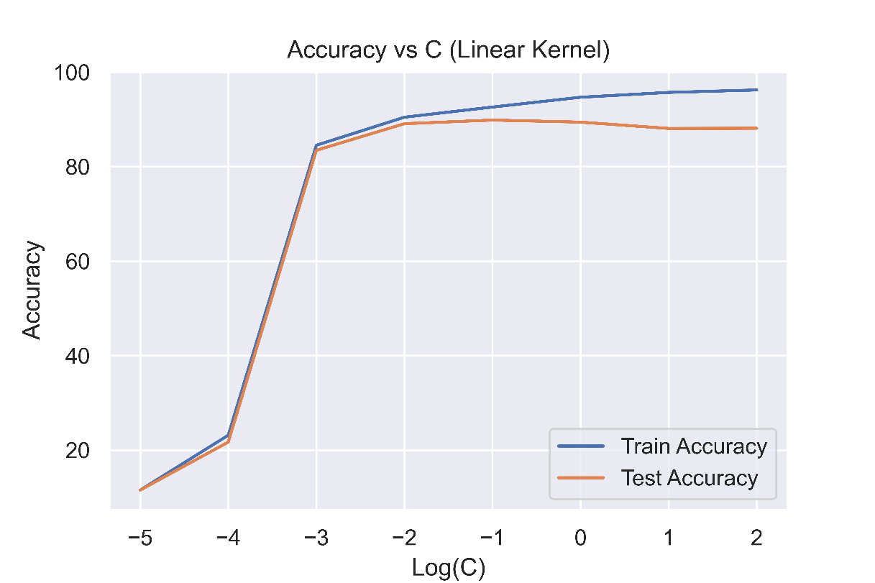

(Accuracy vs C (Linear Kernel) for 25 features)

We get the following results:

|  |  |
| --- | --- |
| C < 0.01 | Underfitting |
| C = 0.01 | Best fit |
| C > 0.01 | Overfitting |

If we switch to **RBF** kernel:

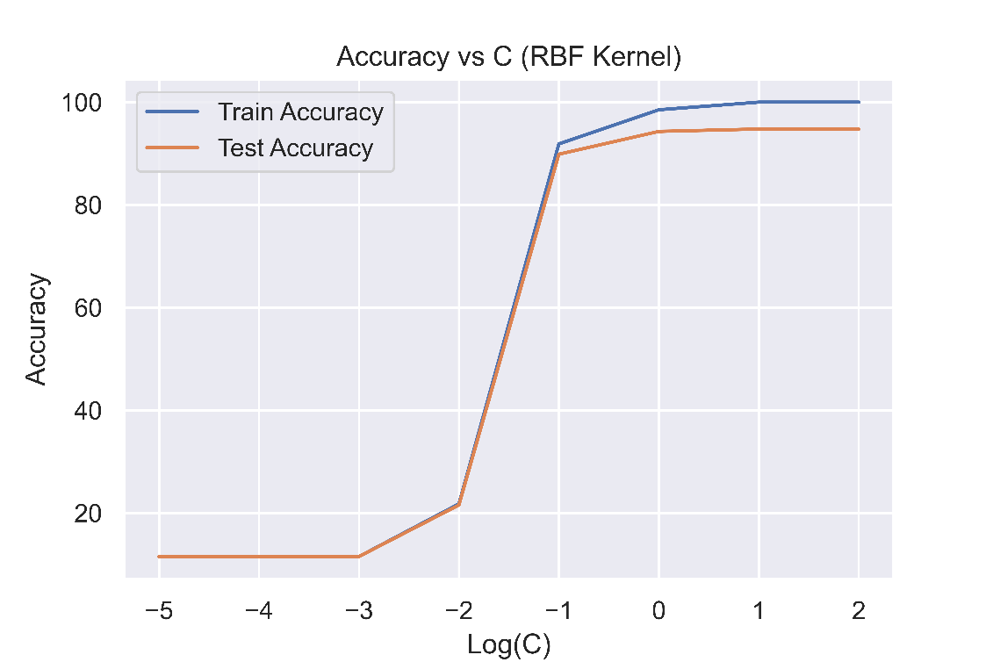

(Accuracy vs C (RBF Kernel) for 25 features)

From here, we get the following results:

|  |  |
| --- | --- |
| C < 1 | Underfitting |
| C = 1 | Best fit |
| C > 1 | Overfitting |

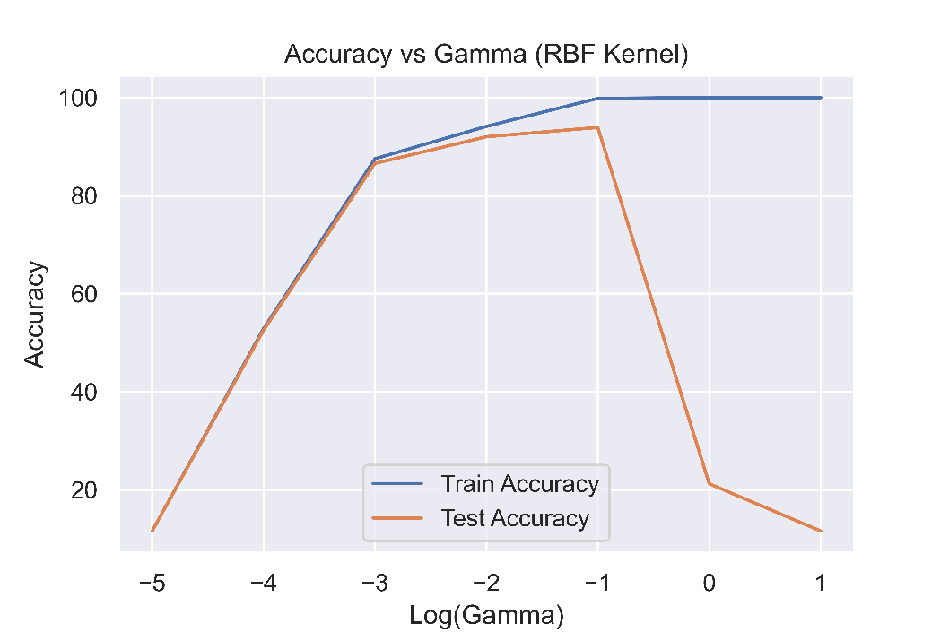

(Accuracy vs γ (RBF Kernel) for 25 features)

|  |  |
| --- | --- |
| γ < 0.1 | Underfitting |
| γ = 0.1 | Best fit |
| γ > 0.1 | Severe Overfitting |

If instead, we use only 10 features, we get the following results:

Using **linear** kernel.

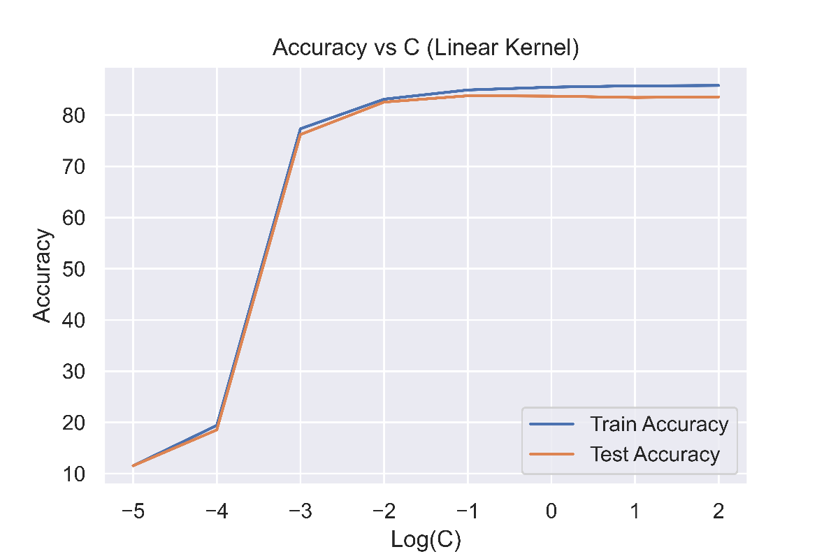

(Accuracy vs C (Linear Kernel) for 25 features)

We get the following results:

|  |  |
| --- | --- |
| C < 0.01 | Underfitting |
| C = 0.01 | Best fit |
| C > 0.01 | Overfitting |

If we switch to **RBF** kernel:

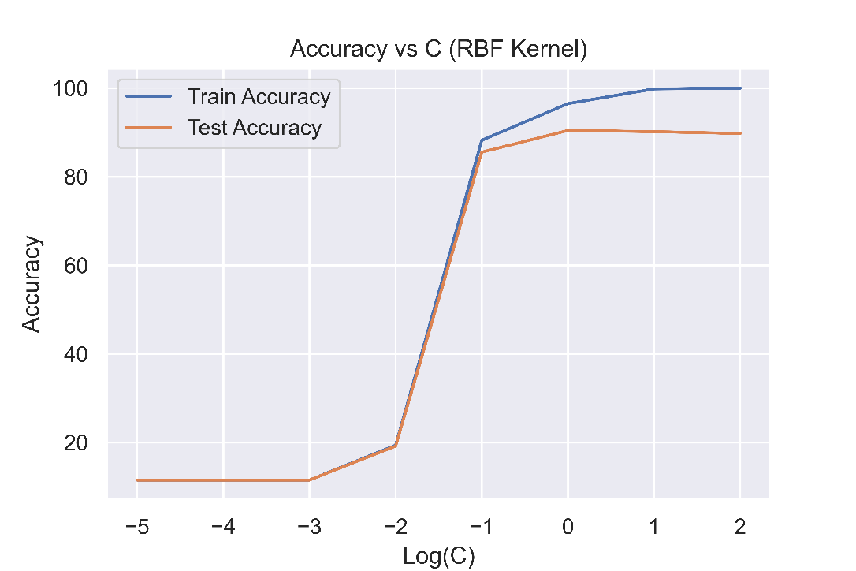

(Accuracy vs C (RBF Kernel) for 25 features)

From here, we get the following results:

|  |  |
| --- | --- |
| C < 1 | Underfitting |
| C = 1 | Best fit |
| C > 1 | Overfitting |

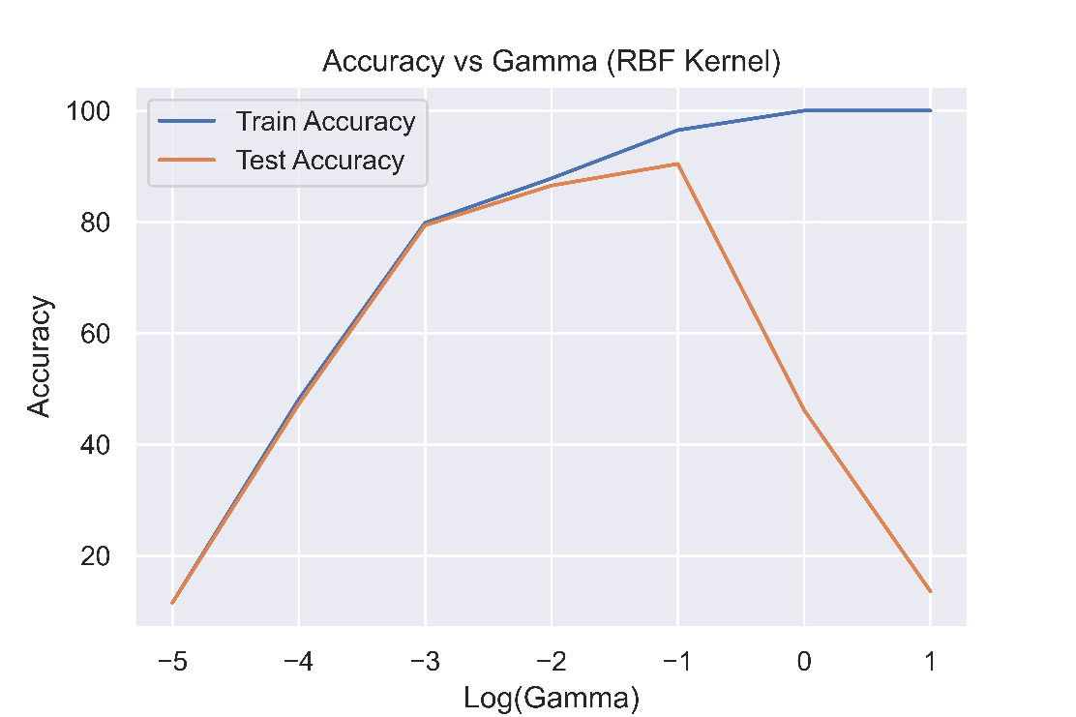

(Accuracy vs γ (RBF Kernel) for 25 features)

|  |  |
| --- | --- |
| γ < 0.1 | Underfitting |
| γ = 0.1 | Best fit |
| γ > 0.1 | Severe Overfitting |

**2.3.3 Fine tuning of parameters**

* + 1. **Difference between using 10 features as compared to 25 features**

1. **Simplified SMO algorithm**

In this part of the assignment, we implement simplified SMO algorithm for solving the optimization problem (instead of the previously implemented CVXOPT approach or the LIBSVM library).

The pseudocode for this algorithm is given at [SMO.pdf](https://web.iitd.ac.in/~sumeet/smo.pdf) and that is implemented as follows:

